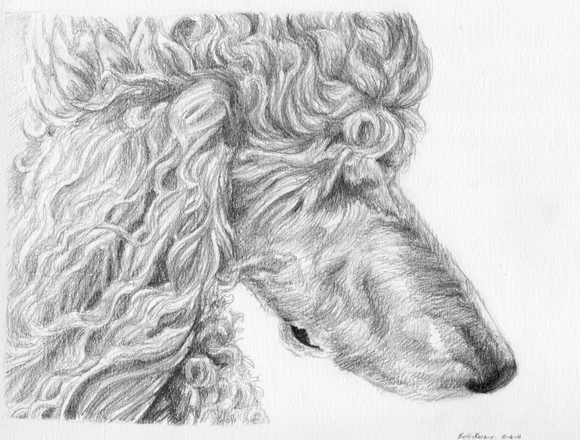
Dittos Standard Poodles Adoption and health contract for Open/Full AKC Registration;
Dittos has the right to refuse a sale to anyone:
This contract is only legally binding to the original buyer and signer of this contract;
PLEASE READ OUR FULL CONTRACT BEFORE COMMITTING AND SIGNING ….
We believe in selling all of our dogs and or puppies to approved pet quality forever homes only. We are not a puppy mill and will not sell to one.

You will receive your Full AKC registration papers at time of puppy being paid in full. Or when contract is fulfilled.
Name of puppy/dog ______________________Date of birth __________________________________
Sex ____________________________________Price of puppy__________________________________
Color and markings _______________________Shipping cost__________________________________

Crate/Cert.______________________________ Deposit given __________________________________

Total owed ______________________________Full AKC Papers_____ ___________________________

Trade on puppy __________________________Military Proof __________________________________
Dam; __________________________________Sire;___________________________________________
Litter registration number; ___________________ Date of last shots/Worming’s___________________
Special Terms of Sale ___________________________________________________________________
_____________________________________________________________________________________
_____________________________________________________________________________________
_____________________________________________________________________________________

Adopter’s full name (please print) _________________________________________________________

Adopter’s signature ____________________________________________________________________
Adopter’s address ______________________________________________________________________

City ________________________________________ State ____________________ Zip code ________
Adopter’s phone # _____________________________Adopter’s Cell # ___________________________

Email _______________________________________ Date of Sale ______________________________
A $300.00 deposit is required to hold a puppy from any of our litters. The remaining balance on price of puppy must be paid in full before the puppy leaves our home to yours. Failure to comply with these terms and conditions will result in the purchaser’s deposit being forfeited. Deposits which are made to hold a puppy are legally binding and are NON-REFUNDABLE.

We accept No personal checks for a final payment on a puppy. We only accept cash as final payment.

We here at Ditto’s Standard Poodles strive to offer quality AKC registered standard poodles fit to be of good pet companions. We operate by the strict procedures of the AKC. Our puppies are guaranteed to be in good health to the best of our knowledge, at the time of sale. This said puppy will be current on all shots necessary to be done at the time of the puppy’s age and shot records will be given.
To validate the health guarantee given, buyer must have their licensed veterinarian do a basic exam on this said puppy/dog within THREE days following the date of signing this agreement and or contract, excluding weekends and holidays. Please note that we (Ditto’s) are not responsible for any of the vet bills or medication bills incurred during this examination this is the new owner’s responsibility.
If your licensed veterinarian finds anything wrong with said sold puppy of any hereditary genetic defaults ( e.g. heart, liver, kidneys ) at the time of the examination, the puppy will be exchanged for another puppy, or if another puppy is not available at that time, then a refund will be made providing a legal letter from your licensed veterinarian with his legal letterhead information (Clinic name, Vet name, address, signature and a valid working phone number, no cell phones accepted), this is offered as evidence of puppies hereditary genetic defaults. After I have received this letter as evidence of the genetic defaults then above said puppy will be returned to me for my second opinion from my licensed veterinarian, at that point the determination will be made that agrees or disagrees of these said findings. This agreement of findings from your veterinarian shall be returned to me (Ditto’s) within 48 hours of the above mentioned period to be valid. Again we are not responsible for any of these vet bills incurred on these said findings from your licensed vet.
This guarantee is not intended to cover said things which are a prone to the breed or other dog breeds that is not proven to be a hereditary genetic default or life threatening to the above said puppy such as and not limited to uneven bites, undescended testicles, umbilical hernias, bilateral conjunctivitis, parasites such as coccidian or giardia, also worms per all puppies are prone to be born with worms.

On rare occasions we can get a puppy that will hold one of these undesirable traits, such as the umbilical hernias or a BNM (base narrow mandible), or bilateral conjunctivitis, these can be a very common but rare trait that will show up in any dog breed but will in no way affect or threaten the way of life of a puppy into adult hood, most commonly 80% of the time the puppy will outgrow these traits on their own without any difficulties but of course there is no guarantee of this, these traits also will not affect anything with the way a puppy plays, looks, sees, feels or chews. These undesirable traits are not proven to be hereditary or genetic or have anything to do with the health testing of said lines.

It is also understood and agreed that this puppy is guaranteed to be AKC registered, that no warranty is given of reproduction, color, breeding capabilities, or size of said puppy has been made.
Your puppy comes with a health immunization record which provides you with information on what shots that your puppy has received and when. Please be aware that it is your responsibility as the adopter of said puppy to make sure that your puppy obtains all recommended future immunizations. We strongly urge you to discuss the remaining shots needed and when they are to be administered with your licensed veterinarian.
We represent your puppy to be of good companion pet quality. By signing this contract the adopter agrees to provide adequate veterinary care throughout the puppies’ life starting after signing of this contract. Neglect after said puppy leaves our premises we do not and cannot give any guarantees on other than what is mentioned above.
Our puppies sold are not being sold on a trial basis, we ask that you please read up on this breed and be committed to your new addition for the life of this puppy, If for some reason out of your control you cannot keep your new puppy after your purchase then Dittos will help you rehome your puppy, by listing him/her on our website and other advertisement and find him/her a new forever family...
This puppy is guaranteed to the original adopter only for 12 Months against any hereditary/genetic defaults and or life threatening diseases (e.g. heart, liver, kidneys) and this puppy is guaranteed for 12 Months against Hip Dysplasia.
Please read our page on hip dysplasia prevention that the buyer can help in the development of puppy’s hips.

Seller is not responsible for the development of non-genetic disqualifying faults, diseases or disorders or any negligence due to buyer’s neglect.
Seller does not assume any liability for injury in any way for said puppy after final transaction is completed and puppy leaves sellers premises.
Dittos has the right to refuse anyone a dog/puppy if we feel that it is necessary no matter who you are, we also can return a deposit to the buyer or full price if one has been given on a puppy if we feel that it is necessary to protect our rights or the dog/puppies rights.

By signing this contract you are agreeing to follow any and all information given on this form. And by signing this form if you get rid of or re home this puppy/dog at any time of their life you are agreeing to let me know the new ownership information (Name/Address/Phone/Email).

We hope that this transition from our home to yours is a successful one and a lifetime of fun and happiness and good health.
Congratulations on your new puppy and we here at Ditto's want to thank you for buying a puppy from us, welcome to our family.

We love updated pictures and love to know how you and the puppy are doing their whole entire life and yours, good or bad. Thank You again from us to you.
Teresa Newsome
Owner/Breeder
Dittos Standard Poodles
t.n.dittos@gmail.com
801-541-3332
WWW.DittosStandardPoodles.com

All FULL AKC registration given must be agreed upon and buyer/signer of this contract must read, initial and sign below before committing and release for full registration rights…
We believe in first and foremost in selling all of our puppies/dogs to approved pet quality homes only, but with that being said on some very special occasions we may allow an open/full AKC registration on a said sold puppy male or female.
Below are my terms on accepting any open/full AKC registration from Dittos, all of these conditions must be agreed upon and signed before an open/full AKC registration is given to anyone.
We here at Dittos are not a puppy mill and will not sell to one or promote one, for any reason at all. This contract below is made in place of any and all AKC rules and regulations in regard to the sale of any said puppy/dog with open/full AKC registration agreement to protect Dittos and my rights along as the said puppy’s rights.
This new owner is aware by signing this contract/Agreement that AKC registration rules and regulations will apply and will be in effect when referring to this sale of open/full AKC registration agreement contract. This contract is enforceable by real legal Utah law and as stated below.
If you resale this puppy/dog bought from us, I will be informed of the transfer with new owner information.
In order for my validation of an Open/Full AKC registration the following has to be initialed and signed before Full AKC papers are given;
- All the puppies sold from this open/full AKC registration mating will not be sold to any pet stores and or any puppy mills.
Initial________
- If you are buying a female puppy from Dittos on an open/full AKC registration you cannot breed her until said female puppy is at least 16-18 months old.
Initial ________

- None of the puppies whelped from this said sold female/male, puppy/dog will be given or sold as open registration without my knowledge and agreed upon by both breeder and new owner. I prefer puppies sold as limited pet homes only to protect my Dittos line if at all possible.
Initial __________

- The said female/male puppy/dog sold as open/full AKC registration will not be kept in a cage or dog run or on a chain for the remainder of their life, like said puppy mills.
Initial_________

- The sold female will not be bred after the age of 8-9 years of age at that point in their life they will be fixed for the remainder of their life.
Initial__________
- The said sold female puppy will only be bred once then skipping a heat cycle after said puppy/dog has whelped a litter.
Initial__________

- When said sold puppy/dog is old enough to breed being at least 18 months old for the female then the new owner will only breed if said sold puppy passes all required genetic tests per AKC including but not limited to Ne/Vwd/Dm/Pra etc. This is to protect the future of the Standard Poodle breeding lines.
Initial__________

- When said sold puppy/dog is old enough to breed being at least 18 months old for the female then the new owner must only breed with health tested lines as well which has to be reinforced by every 2nd generation.
Initial___________

- If above sold puppy/dog is being rehomed it’s your duty to insure the above requirements exist in this contract and it’s your duty to transfer me any new owner information including and not limited to new owner name/address/phone/email.
Initial __________

- Buying our puppies with Full AKC registration you are required to use our Kennel name “Dittos” in your new puppies registered name.
Initial __________

By signing below, you the new owner of said puppy/dog acknowledge that you have read, understand and agree to the above terms and conditions of said open/full AKC contract agreement or Trade.
Dated this __________________day of _____________________, 20______________.
New owner of above said sold puppy with Full AKC Registration agrees to all information on this form by signing and initialing this Contract.

New owner signature _________________________________________________________

