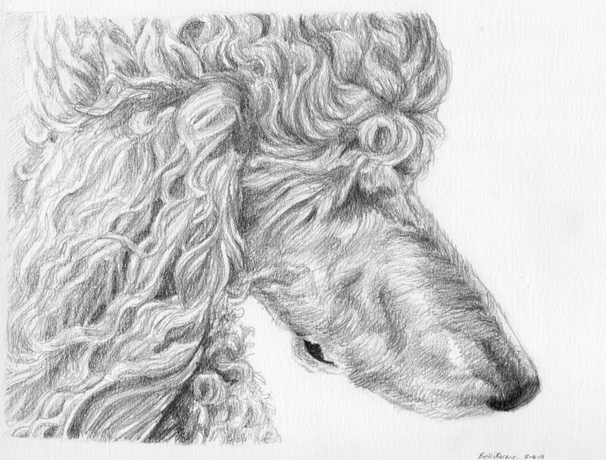

Dittos Standard Poodles Adoption and health contract for Spay/Neuter;
Dittos has the right to refuse a sale to anyone:
This contract is only legally binding to the original buyer and signer of this contract;
PLEASE READ OUR FULL CONTRACT BEFORE COMMITTING AND SIGNING….
We believe in selling all of our dogs and or puppies to approved pet quality forever homes only. We are not a puppy mill and will not sell to one.

You will receive your LIMITED AKC registration papers after verification of Spay/Neuter from veterinarian.
Name of puppy/dog ______________________ Date of birth _________________________________
Sex ____________________________________ Price of puppy_________________________________
Color and markings ______________________ Shipping cost__________________________________

Crate/Cert. _____________________________ Deposit given __________________________________

Total owed ______________________________Limited AKC Papers _____________________________

No AKC Papers ___________________________Military Proof _________________________________
Dam; __________________________________Sire;___________________________________________
Litter registration number; ___________________ Date of last shots/Worming’s___________________
Special Terms of Sale ___________________________________________________________________
_____________________________________________________________________________________
_____________________________________________________________________________________
_____________________________________________________________________________________

Adopter’s full name (please print) _________________________________________________________

Adopter’s signature ____________________________________________________________________
Adopter’s address ______________________________________________________________________

City ________________________________________ State _________________ Zip code ___________
Adopter’s phone # _____________________________Adopter’s Cell # ___________________________

Email ________________________________________Date of Sale ______________________________
By signing this contract you are agreeing to everything on here…

Seller requires that pups sold with limited Registration are to be spay/neutered before 12 months from date of birth in order to preserve seller’s bloodlines and for the general health and well-being of this said puppy sold. This also means any breeding (‘s) of said sold puppy/dog from this seller. Failure to spay/neuter in accordance with this agreement shall render all guarantees/warranties null and void. Buyer shall be liable for liquidation damages of $ 15,000.00 to be paid to the seller if these provisions are violated. No AKC paperwork will be given until proof of Spay/neuter of above said puppy/dog.

A $300.00 deposit is required to hold a puppy from any of our litters. The remaining balance on price of puppy must be paid in full before the puppy leaves our home to yours. Failure to comply with these terms and conditions will result in the purchaser’s deposit being forfeited. Deposits which are made to hold a puppy are legally binding and are NON-REFUNDABLE.

We accept No personal checks for a final payment on a puppy. We only accept cash as final payment.

We here at Ditto’s Standard Poodles strive to offer quality AKC registered standard poodles fit to be of good pet companions. We operate by the strict procedures of the AKC. Our puppies are guaranteed to be in good health to the best of our knowledge, at the time of sale. This said puppy will be current on all shots necessary to be done at the time of the puppy’s age and shot records will be given.
To validate the health guarantee given, buyer must have their licensed veterinarian do a basic exam on this said puppy/dog within THREE days following the date of signing this agreement and or contract, excluding weekends and holidays. Please note that we (Ditto’s) are not responsible for any of the vet bills or medication bills incurred during this examination this is the new owner’s responsibility.
If your licensed veterinarian finds anything wrong with said sold puppy of any hereditary genetic defaults ( e.g. heart, liver, kidneys ) at the time of the examination, the puppy will be exchanged for another puppy, or if another puppy is not available at that time, then a refund will be made providing a legal letter from your licensed veterinarian with his legal letterhead information (Clinic name, Vet name, address, signature and a valid working phone number, no cell phones accepted), this is offered as evidence of puppies hereditary genetic defaults. After I have received this letter as evidence of the genetic defaults then above said puppy will be returned to me for my second opinion from my licensed veterinarian, at that point the determination will be made that agrees or disagrees of these said findings. This agreement of findings from your veterinarian shall be returned to me (Ditto’s) within 48 hours of the above mentioned period to be valid. Again we are not responsible for any of these vet bills incurred on these said findings from your licensed vet.
This guarantee is not intended to cover said things which are a prone to the breed or other dog breeds that is not proven to be a hereditary genetic default or life threatening to the above said puppy such as and not limited to uneven bites, undescended testicles, umbilical hernias, bilateral conjunctivitis, parasites such as coccidian or giardia, also worms per all puppies are prone to be born with worms.

On rare occasions we can get a puppy that will hold one of these undesirable traits, such as the umbilical hernias or a BNM (base narrow mandible), or bilateral conjunctivitis, these can be a very common but rare trait that will show up in any dog breed but will in no way affect or threaten the way of life of a puppy into adult hood, most commonly 80% of the time the puppy will outgrow these traits on their own without any difficulties but of course there is no guarantee of this, these traits also will not affect anything with the way a puppy plays, looks, sees, feels or chews. These undesirable traits are not proven to be hereditary or genetic or have anything to do with the health testing of said lines.

It is also understood and agreed that this puppy is guaranteed to be AKC registered, that no warranty is given of reproduction, color, breeding capabilities, puppy’s hair, or size of said puppy has been made.
Your puppy comes with a health immunization record which provides you with information on what shots that your puppy has received and when. Please be aware that it is your responsibility as the adopter of said puppy to make sure that your puppy obtains all recommended future immunizations. We strongly urge you to discuss the remaining shots needed and when they are to be administered with your licensed veterinarian.
We represent your puppy to be of good companion pet quality. By signing this contract the adopter agrees to provide adequate veterinary care throughout the puppies’ life starting after signing of this contract. Neglect after said puppy leaves our premises we do not and cannot give any guarantees on other than what is mentioned above.
Our puppies sold are not being sold on a trial basis, we ask that you please read up on this breed and be committed to your new addition for the life of this puppy, If for some reason out of your control you cannot keep your new puppy after your purchase then Dittos will help you rehome your puppy, by listing him/her on our website and other advertisement and find him/her a new forever family...
This puppy is guaranteed to the original adopter only for 12 Months against any hereditary/genetic defaults and or life threatening diseases (e.g. heart, liver, kidneys) and this puppy is guaranteed for 12 Months against Hip Dysplasia.
Please read our page on hip dysplasia prevention that the buyer can help in the development of puppy’s hips.

Seller is not responsible for the development of non-genetic disqualifying faults, diseases or disorders or any negligence due to buyer’s neglect.
Seller does not assume any liability for injury in any way for said puppy after final transaction is completed and puppy leaves sellers premises.
Dittos has the right to refuse anyone a dog/puppy if we feel that it is necessary no matter who you are, we also can return a deposit to the buyer or full price if one has been given on a puppy if we feel that it is necessary to protect our rights or the dog/puppies rights.

By signing this contract you are agreeing to follow any and all information given on this form. And by signing this form if you get rid of or re home this puppy/dog at any time of their life you are agreeing to let me know the new ownership information (Name/Address/Phone/Email).

We hope that this transition from our home to yours is a successful one and a lifetime of fun and happiness and good health.
Congratulations on your new puppy and we here at Ditto's want to thank you for buying a puppy from us, welcome to our family.

We love updated pictures and love to know how you and the puppy are doing their whole entire life and yours, good or bad. Thank You again from us to you.
Teresa Newsome
Owner/Breeder
Dittos Standard Poodles
t.n.dittos@gmail.com
801-541-3332
WWW.DittosStandardPoodles.com

