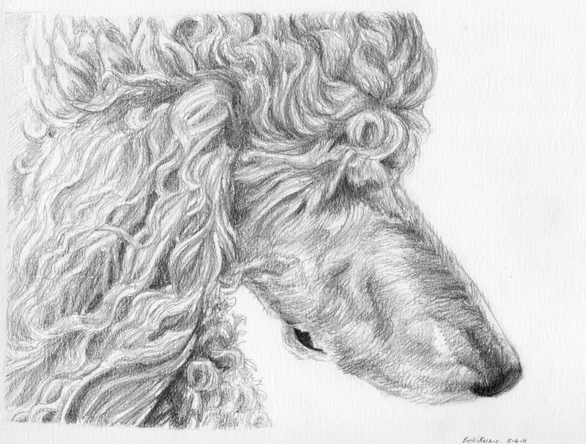

Dittos Standard Poodles Deposit Agreement;
Dittos Standard Poodles always has the right to refuse a sale to anyone;
This Deposit Agreement is legally binding to the original buyer and signer to this contract;
ON THIS DATE: ________________________________________________________________________
Dittos Standard Poodles has agreed to sell to the below named (BUYER) placing a deposit on below said puppy/dog, in the amount of $300.00 Buyer agrees by signing this contract that deposit given is a nonrefundable monies (DEPOSIT) as said in original buying contract.
DEPOSIT ON PUPPY/DOG BEING SOLD:
Breeding dam and sire: __________________________________________________________________
Puppy call name/collar color: _____________________________________________________________
Color of pup on deposit given: ____________________________________________________________
SELLER:
DITTOS STANDARD POODLES (TERESA NEWSOME)
BUYER INFORMATION:
(PLEASE PRINT LEGIBLE)
FULL Name: ___________________________________________________________________________
FULL Address: _________________________________________________________________________
Phone Number: ________________________________________________________________________
Email: _______________________________________________________________________________
MONIES AGREED ON:
Full purchase price of said puppy/dog: _____________________________________________________
Deposit of $300.00 given by way of:
PayPal/Cash/Personal check/Postal Money order _____________________________________________
This is considered part of initial amount of purchase price on said puppy/dog of the remaining balance of: __________________________________________________________________________________
Seller will hold the above mentioned puppy/dog for the buyer until agreed pickup date of:
_____________________________________________________________________________________
Any exceeding days after agreed pick up date mentioned above will be an addition charge on the (BUYERS) part of $50.00 a week to maintain food/shots/up keep of said dog/puppy. This amount will be added to remaining balance.
Additional Monies Incurred with holding said dog/puppy: ______________________________________
The balance due at time of pick up is: ______________________________________________________
This amount still remaining on said puppy/dog will be paid in CASH ONLY for final payment on pick up date.
By signing this agreement you are agreeing to all written information on this form and agreeing that if you as the (BUYER) backs out of the sale of this said dog/puppy that there is no refund given on this said deposit which is a nonrefundable deposit. Buyer also certifies that they have read Dittos Standard Poodles adoption contract in full before completing this deposit.
Seller also reserves the right to void this transaction and refund the deposit for any reason. If, through some tragic unexpected accident, the dog were to die or otherwise be seriously injured before it is picked up, then this said deposit will be returned to the original buyer OR, if the buyer wishes, said deposit of $300.00 can be applied to another dog/puppy, if one is available or to a puppy from the next litter available.
**Please note that deposits on un-born or unspecified puppies: if a suitable puppy does not become available within 1 year of receipt of the deposit, the buyer will be given the option to have the deposit returned or continued to the next available litter.

Buyers Signature _______________________________________________________________________
On this date of: ________________________________________________________________________

