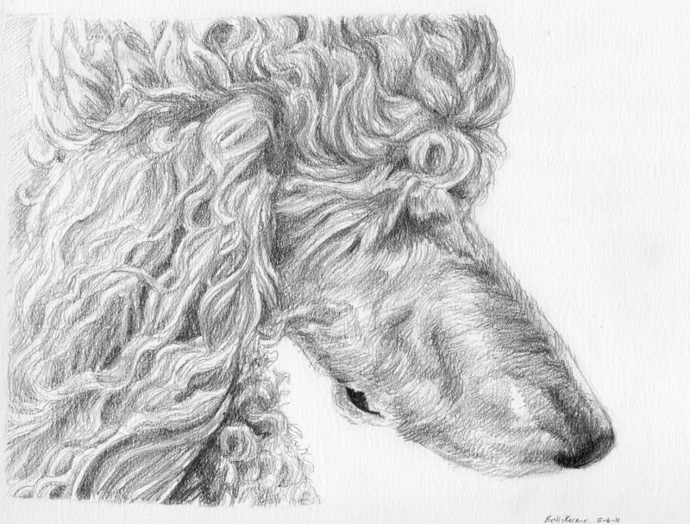

STUD SERVICE AGREEMENT;
Ditto’s has the right to refuse any prospective client at any time. This agreement is only valid with the original AKC owner of said Dam dog.
I, Teresa Newsome, am the sole owner of _________________________________whom is being used for the stud service by _________________________________________for his/her female ___________________________________.
The stud service amount for this contract is $1,200.00. The stud service fee is due at the time of service rendered. I guarantee the female bred or I will offer a one-time return breeding within 12 months of the original breeding. I guarantee at least one live puppy or I will offer a onetime return breeding within 12 months of the original breeding.
Stud service will be done at my place of residence or if agreed upon other residence. The said female will be delivered to me during her heat cycle and will most likely be here at least 3 days. There is no fee for boarding the female during these 3 days, however if the female remains longer than the 3 days there will be a $20.00 per day boarding fee due prior to or at the time of picking the female up.
The female must have proof of being free from Brucellosis and have her current vaccinations. This test must have been done no more than 30 days prior to the time of mating. The test is done for both of our dog's safety and future health. And also genetic testing’s of at least OFA, VWD, NE, DM.
This contract is made in place of any and all AKC rules and regulations in regard to dam or sire owner's rights. This dam owner is aware of AKC registration rules and regulations do not apply and are not in effect when referring to this stud service and its contract. This contract is enforceable by real legal law and as stated below.
All puppies produced by way of this mating will be placed by the dam owner as pets only for their entire lifetime, and on LIMITED AKC REGISTRATION applications and/or papers, along with a pet contract. Only full AKC registration given up agreement between both parties in this said contract. The dam owner agrees that if any conditions or terms of the above contract are violated by the dam owner, the dam owner will pay restitution to the sire owner. Restitution of $1200.00 per each puppy and for each violation. If the contract needs to be enforced by way of court it is agreed that all court costs and legal fees incurred will be paid by the dam owner, all actions will be in Utah Court and be subject to Utah Laws.
The dam's owner/owner's will be responsible for screening new owners, choosing the purchase prices, and choosing pet homes as clarified above. The dam's owner is also responsible for all maintenance, health, guarantees and care of the puppies produced by this mating.
All the puppies sold from this mating will not be sold to any pet stores or puppy mills! None of these puppies will be sold to reproduce any mixed dog breeding.
The dam's owner/owner's guarantee that the dam is of at least 18 months of age and is no more than 7 years of age.
By signing below, I acknowledge that I have read, understand and agree to the above terms.
Dated this day of ______________ and month of __________________, 20____.
Stud owner ___________________________________________________________________
Dam owner ____________________________________________________________________

